|  |  |  |  |  |
| --- | --- | --- | --- | --- |
|  |  | |  | | --- | | ARCASN Newletter  June 2019  Issue 2 | |  | |
|  |  |  |
|  |  | In This Issue |

***Note from our President***

first memory of really wanting to be involved in ARCASN happened when I participated in the 2007 Annual conference organized by UNB SJ where I met some amazing and passionate educators from all over

Atlantic Canada. In the bathroom of all places, I was approached by the Chair of the Education Committee who told me about the different grants that ARCASN gives out each year. I not only ended up representing my school of nursing on the committee, I later went on to receive both Education and Research Grants. If you’ve been a member for a while and wonder, what else can I give to and get out of ARCASN, take the plunge and become a school rep, sit on one of the two committees or even think about becoming president, treasurer or secretary. It’s been a wonderful journey so far, come join me!

Best wishes for a restful summer and a wonderful 2019-2020 year!

Sincerely,

Suzanne Harrison, RN, PhD

Note from our President 1

Highlights from membership schools 1

Gems from CASN Council Nov 2018 2

News from CASN Executive Director 2

Membership List for 2018-2019 3

New Lifetime members 4

Publications from ARCASN members 5

ARCASN Awards 2018 6

News about the 2020 conference 7



**At a glance: Highlights from our membership schools**

**CBU –**T he name of our school has changed to the School of Education and Health. Nursing Faculty and NPEs continue to be involved in various scholarly and research activities.

**CNS –** Preparing for the second year of the newly implemented concept-based curriculum. The new curriculum is receiving positive feedback from students and faculty...so far!"

**DAL –** Dalhousie is at full enrolment in our new undergraduate curriculum with the first cohort graduating with 100% NCLEX success.  Path B accreditation visit is scheduled for March 2020.  Our graduate programs include a Master of Science in Nursing (MScN) with thesis, a Master of Nursing, Nurse Practitioner or course based Professional Stream, and a PhD. All programs are thriving and welcoming applicants.

**MUN –** Preparations are ongoing for the second year of the newly implemented concept base curriculum and the new Accelerated Option (which replaces the former Fast Track option) will commence this Fall 2019.

**SFX –** Happy to host the ARCASN conference this year

**U de M -** Suzanne Harrison has been named the new director of the School of Nursing for U de M. Her mandate starts on July 1st and is for 3 years.

**UNB –** Increased seats in the BN program at both Fredericton and Moncton sites.

**UNB SJ –** UNB Saint John is proud of the success of its students, and the broad research agendas including becoming a JBI Centre of Excellence.

**UPEI –**Received a seven-year Accreditation from the Canadian Association of Schools of Nursing, the national accrediting body for nursing education in Canada in 2018. Dr. Jo-Ann MacDonald is currently our Acting Dean of the Faculty of Nursing.

**WRSON -–** Preparations are underway for expansion of concept based curriculum into second year, with new accelerated program to be rolled out Fall 2019.

Dear Colleagues:

Welcome this year’s ARCASN newsletter. I am just finishing up my first year as president, but I am no stranger to the executive. I think my

# CASN logo

**CASN Council Nov 2018**

**The Canadian Association of Schools of Nursing Council meeting took place in Ottawa in November.**

Suzanne Harrison (ARCASN President) attended Council. Some highlights:

1. During the **Graduate Studies Forum**, the following themes were discussed: 1: Advancing indigenous health & nursing in graduate curricula, 2: What is “quality” in graduate education? 3: Exploring quality indicators at Canadian schools of nursing, and 4: Supporting the next generation of students and recruitment of Faculty. At the Annual General Meeting, the topic of Recruitment and Retention of Faculty included a look at how to recruit and retain the next generation of faculty and academic leaders, exploring what new faculty and administrators are looking for, and what keeps faculty at “home”. Stop Juggling and Start Balancing was also presented wherein experienced academic leaders gave their life hacks on how to balance student, faculty, and program issues, while avoiding burn out

2. Annual Lecture with the **2018 Pat Griffin Scholar**,Dr. Linda Fergusson, who has been involved in nursing education research for the past thirty years, studying various aspects of nursing education, with a particular focus on clinical learning.

3. **Evolving scope of RN practice** was addressed by a panel discussion that explored the expanding scope, expectations and specializations of RN roles, and how we prepare students today for the health care system of tomorrow. Also a group discussion included ideas for how the different schools have responded to the realities and changes in respective provinces.

4. Executive Director, Marilee Nowgesicon of the Canadian Indigenous Nurses Association’s (CINA) and Isabelle Wallace spoke of **advancing indigenous health and the implications for nursing education**.

5. Ideas were put forward for how best to work together in preparing the next generation of R

Ns for **effective inter-professional collaboration** through moving beyond our silos and from theory to practice.

6. The topic of using **simulation to prepare nursing students for the future** provided innovative teaching strategies with simulation technology in the undergraduate nursing curricula.

Dr. Cynthia Baker, Executive Director, Canadian Association of Schools of Nursing, will speak at the conference!

News from CASN, our national schools of nursing partner

Membership List for 2018-2019

**CBU (9)**

Debbie Brennick

Debbie Cantwell

Odette Griscti

Tracy Lillington*

Cyndee MacPhee

Willena Nemeth

Lilla Roy

De-Ann Sheppard

Audry Walsh

**CNS (3)**

Jeanette Cronin

Glenys Moran*

Gladys Schofield

**Dal (19)**

Danielle Byrne

Shelley Cobbett

Lisa Doucet

Jacqueline Hartigan-Rogers

Deborah Hartter Kim Hebert

Kim Hebert

Shauna Houk*

Kelly Lackie

Adele LeBlanc

Marilyn MacDonald

Karen MacRury-Sweet

Betty McIssac

Joanne Newell

Sandra Redmond

Carol Ritchie

Debra Shephard-Lemoine

Catherine Simpson

Debbie Viel

Adele Vikic

**MUN (5)**

Mary Bursey

Renee Crossman*

Alice Gaudine

Robert Meadus

Nicole Snow

**St FX (13)**

Marion Alex*

Marie Arnott

Donna Cabrera

Daphne Connolly

Anne Marie Dobbin

Sionnach Lukeman

Cathy MacDonald

Michelle MacNeil

JWendy Panagopoulos

Janet Purvis

Melanie Soe Deveau

Joanne Whitty-Rogers

Susan Wood

**U** **de M (35)**

Suzanne Bastarache

Julie Boudreau

Amélie Boulay

Rachel Boudreau-St.Eloy

Anne Charron

France Chassé

Melanie Darveau

Geneviéve Desrosiers

Marjolaine Dionne

Vicky Doiron

Chad Doucet

Anik Dube

Annie Duguay Ferguson

Suzanne Dupuis Blanchard

Suzie Durocher-Hendrick

Tina Edmond

Sophie Gautreau

Caroline Gibbons

Pierre Godbout

Caroline Hachey

Suzanne Harrison

Liette-Andrée Landry

Lucie-Anne Landry

Isabelle Laplante-Deschenes

France Laplante-Theriault

Mélanie Larocque

Nathalie LeBlanc

Natacha LeBreton

Norma Melanson

Benoit Morin

Lisa Morin

Marie-Noelle Paulin*

Anne Pelletier

Cynthia Roy Legacy

Julie Vienneau

**UNB F & M (12)**

Mary Lou Batty

Donna Bulman

Lorna Butler

Nancy Doiron-Mallet

Becky Fullarton

Sharon Hamilton

Cheyenne Joseph

Monique Maillet-Boucher

Tracey Rickards

Kate Weaver*

Stephen VanSlyke

Anne Whalen

**UNB SJ (11)**

Shelley Doucet

Lisa Keeping-Burke

Dana Manzer*

Angela March

Kathleen Mawhinney

Rose McCloskey

Daniel Nagel

Cathy O’Brien-Larivee

Pamela Pasterik

Loretta Waycott

Kimberly Wilbur

**UPEI (4)**

Jo-Ann MacDonald

Janet Bryanton

Gulrose Jiwani

Janet MacIntyre*

**WRSON (7)**

Peggy Colbourne

Peggy Hancock*

Erica Hurley

Daphne Kennedy

Pam Moores

Rebecca Newton

Anne Wadhwa

**Total as of May 21, 2019 = 118**

**\* School rep**

New Lifetime Membership Recipients 2018!

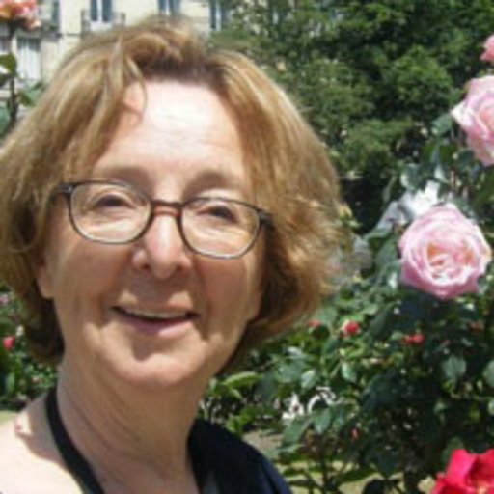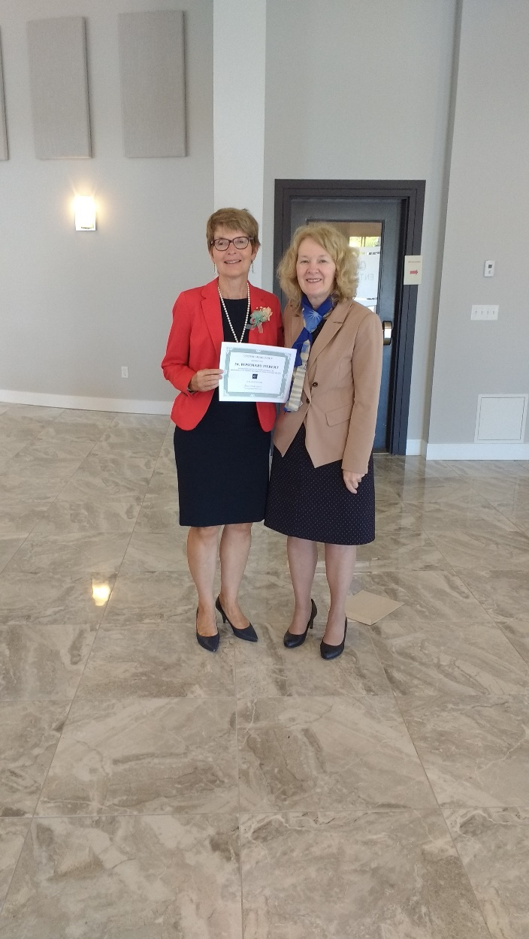

**Dr. Rosemary Hebert**, BN, RN, MN (Dalhousie); PhD (McGill) was awarded Lifetime Membership at the June 2018 Annual General Meeting [photo of Dr. Hebert (left) with outgoing president, Dr. Joanne Rogers.].

Dr. Herbert, a former well-respected Dean of the UPEI School of Nursing, has been a faithful and loyal ARCASN member for many years. She was the proud host of the ARCASN Conference & Annual General Meeting held at UPEI in 2014 and enjoys attending ARCASN Conferences and Annual General Meetings each year. Dr. Herbert is a past Reviewer for the Canadian Association of Schools of Nursing Accreditation Team.

See [www.arcasn.ca](http://www.arcasn.ca) for list of ARCASN Life members and information on how to nominate a Life Member

At the 2018 AGM, ARCASN acknowledged Dr. Danielle Charron’s contribution to ARCASN and nursing education by bestowing her a Lifetime membership. Danielle became a professor at the Université de Moncton’s (UdeM) school of nursing in 2000. At the same time that she was president elect, she was also her school representative from 2006-2008. She was ARCASN’s president from 2008-2010 and during this time, she was instrumental in helping organize the annual ARCASN conference at U de M in 2009 which coincided with CASN’s annual conference.

### Upcoming Publication from ARCASN 2018

Please check out the new publication by members who presented at the Cape Breton ARCASN conference held October 2018 with its theme of *Celebrating Difference: Indigenous and Intercultural Diversity in Nursing Education.*

• *The Significance of Preplanning and Faculty Engagement in Curriculum Change*

*Authors: Shelley Cobbett and Mary van Soeren*

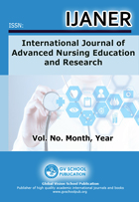

**Vol. 4, No.1, 2019**

*Please note that opportunities to submit manuscripts to the International Journal for Advanced Nursing Education and Research Volume 4 (No 2) 2019 will be provided to presenters at the 2019 conference at SFX.*



**Kathryn Weaver**

Education Award Recipient for 2018!

*Ethical Quest for Student Nurses* is a state-of-the-art, modifiable classroom game designed for use in nursing education to help students learn ethical concepts and pathways for choosing plans of action to address ethical issues. This game was inspired by the continuous changes in the health care system, in areas such as technology and organizational values, which contribute to ethical challenges in the workplace for nurses. The game is operated through standard audiovisual classroom technology and has the built-in feature of randomly selected questions from a bank of approximately 100 questions developed from the CNA Code of Ethics for Registered Nurses, Tri-Council Policy Statement for Ethical Conduct in Research with Humans, CNA position statements, and relevant bioethics and nursing literature.

**ARCASN EDUCATION AWARD**



Nursing is described worldwide as an ethical profession because of its social mandate to alleviate suffering and improve the health and welfare of vulnerable individuals, families, communities, and societies. For nursing to thrive as a profession, there is a need to comprehensively understand the development of nurses’ capacity to recognize and respond to ethical issues. My mixed-methods study titled “Student nurse ethical sensitivity in clinical practice settings” has built on my dissertation research and enabled a beginning measure of ethical sensitivity for Canadian nursing students. Forty-four nursing students from three UNB programs and campuses completed an online questionnaire. The results are similar to those reported internationally, with no significant differences in levels of ES across programs. However, an increase in ES development between Undergraduate/ Advanced Standing to Master level programs is suggested. The nursing students’ stories convey threats to client autonomy and safety, unethical student treatment, and workplace power differentials. Lingering moral residue of shame and guilt is apparent. From these findings, developing student nurse ES in the clinical field requires ethics training, time for reflection, opportunities for open discussion with relevant stakeholders who include clients and families, and support from nursing and team leaders.

**Kathryn Weaver**

**ARCASN RESEARCH AWARD**

I was so happy to receive the Research Grant for the phenomenological study, The waiting game and how it affects resiliency in women.

According to the Canadian Cancer Society, every day 565 Canadians receive the unfortunate news that they have cancer and women often face gender-associated cancers. Between the first physical manifestations and the hopeful period of remission, these women enter a perpetual waiting game. This study seeks is to better understand how the waiting game affects resiliency in women who are diagnosed with cancer or to whom cancer was suspected.

To date, I have had the privilege of hearing six women’s stories. Having personally experienced the waiting game on two occasions and fearing I would hear those words «You have cancer», I wanted to discover other women’s experiences. That data collection continues into the summer of 2019, then on to interpretive analysis in the early fall. I am already planning to follow up with part two, the same study but with women who are internationally born (new master’s student) and eventually, with men (in 2020). ARCASN’s Research Grant got to ball rolling and I am very grateful.

**Suzanne Harrison**



**ARCASN RESEARCH AWARD**

Research Awards Recipients for 2018!

### Annual General Meeting 2019

## .

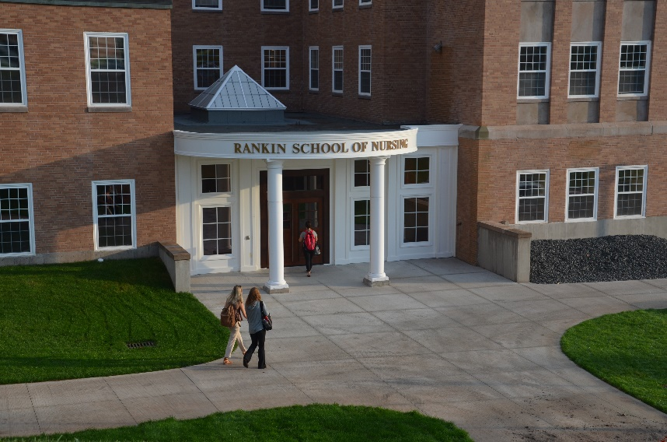.

Our annual general meeting is being held at St. Francis Xavier University June 13-15. The accompanying conference theme is “Ethics in Nursing: Fostering a Moral Climate of Care for Nursing Research, Practice & Pedagogy.” The keynote speaker is Dr. Franco A. Carnevale, a nurse, psychologist, and clinical ethicist

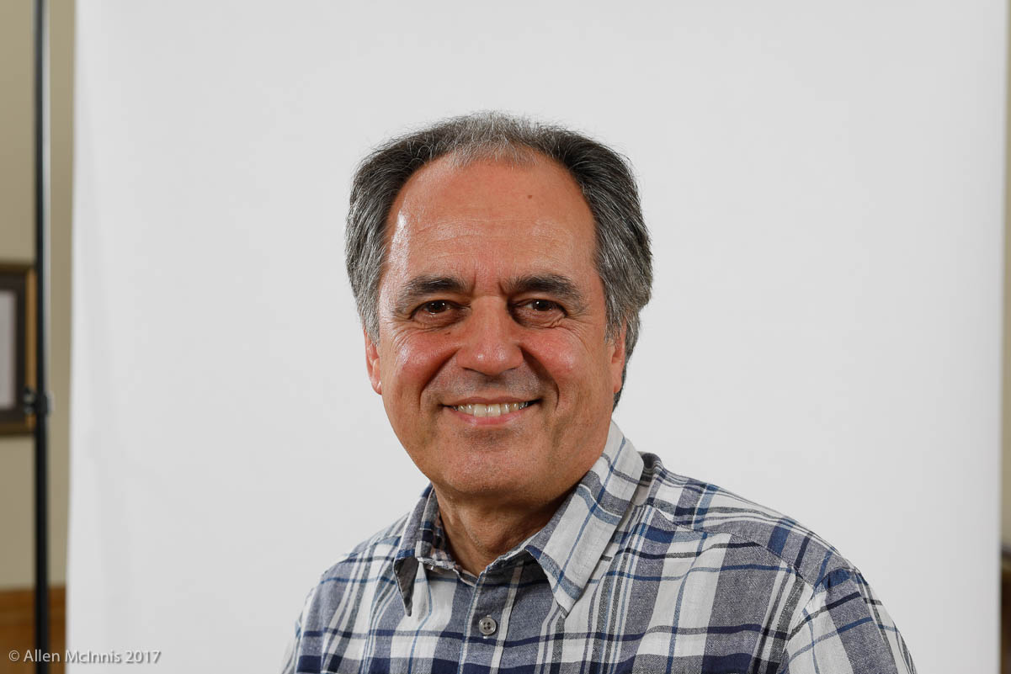

Dr. Kyra Garson

The 2020 ARCASN AGM and Conference will be held at Dalhousie University. Info to follow on [www.arcasn.ca](http://www.arcasn.ca)

Please submit ideas or items for the newsletter to any member of the Editorial Team. We anticipate distribution of the newsletter with future AGMs. It will continue in digital format.

**ARCASN Newsletter Editorial Team**

Editor . . . . . . . . . . . . . . . . Kathryn Weaver UNB [kweaver@unb.ca](mailto:kweaver@unb.ca)

Associate Editors . . . . . . Joanne Whitty-Rogers SFX [jrogers@stfx.ca](mailto:jrogers@stfx.ca)

Peggy Hancock WRSON [phancock@grenfell.mun.ca](mailto:phancock@grenfell.mun.ca)

Odette Gristi, CBU [odette_griscti@cbu.ca](mailto:odette_griscti@cbu.ca)